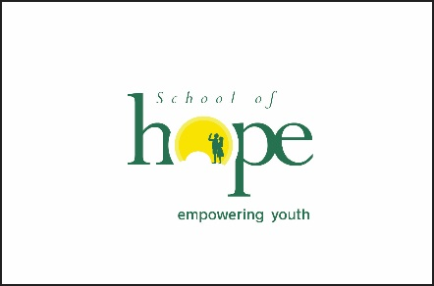
Sponsor a Student at St. Al’s!

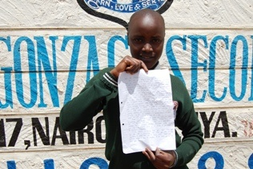
With a gift of $2000 or more you can sponsor a high school student at. St. Aloysius Gonzaga Secondary School. Your gift covers the annual ‘cost of tuition, textbooks, meals, supplies, basic medical care, uniforms, school trips, and other fees incurred by students. Your sponsored student will write letters and share his/her experiences at St. Al’s. You are invited to send letters in response.

Yes, I wish to sponsor a student! (or renew sponsorship)

_____ My gift today will sponsor 1 scholastic year (remind me the following year)

_____ I’m renewing my yearly sponsorship donation
____ My gift today will sponsor 4 scholastic years (I’ll receive letters but no reminders!)

____ I’m renewing my 4 year sponsorship donation

Name: ______________________________________________________________________

Address: ____________________________________________________________________

City/State/Zip: _____________________________________________________________

Phone #: ____________________________________________________________________

Email address: ______________________________________________________________

Thank you for your generosity!
Please make your contribution on the School of Hope website at www.schoolofhopekenya.org/donate or reply by email to Cristine Pope, School of Hope Foundation Director at cristinepope@schoolofhopekenya.org or by mail at School of Hope Foundation, PO Box 12453, Chicago IL 60612.

